# A web based application which helps a user to manage his profile. The user needs to be registered in the system before he can log into the application. Also new user has the ability to register themselves in the application.

## Feature List:

1. Configuration via SPRING including hibernate.
2. New Layer in Architecture Layer called Business Layer.
   1. FrontController calls(requestDispather) ProcessController/PageController

which Autowires **Service Layer**

which Autowires DAO layer

which Autowries SessionFactory.

1. Service Layer Responsibility
   1. Register user only if username doesn’t exists. Service need to check if username exists before creation.
   2. Validates username and password
   3. Saves data either at every step or final step.

1. Ability for a registered user to log into the system, where the username and password is mentioned in the database.

**NOTE: HIBERNATE for INSERT/SELECT**

1. Registration Fields. (All Fields Are required)
   1. First Name
   2. Last Name
   3. User Name
   4. Password
   5. Date of Birth
   6. Email
   7. Mobile Number
2. **HTML 5 / JavaScript validation for the above fields.**
3. **Data would be inserted into a Table.**
4. **Registration Page will use Redirect to Login Page. (POST/REDIRECT/GET)**
5. Profile should contain the following category.
   1. About Yourself
      1. Lines about yourself
      2. Address Line 1
      3. Address Line 2/ Apt #
      4. City
      5. State
      6. Zip
      7. Area of Interest (Check Boxes)
   2. Education Info (Required at least 1)
      1. College Name
      2. Year (Drop-down)
      3. Degree Name (Graduate/Masters/PhD)
      4. GPA (Range from 1.0 to 4.0 / Percentage)
   3. Academic Project (Required at least 1)
      1. Project Name
      2. Company Name
      3. Duration
         1. From Date – To Date
      4. Short Description
   4. Skill Set (Graphical output - Progress Bar as output)
      1. Display 5 Languages (Range 0 – 10).
   5. **Places of Visited (Maps as output)**
      1. lat/lng
      2. Alternates are ok. ( Location Dropdown or .. )
   6. Any additional information also needs to be captured.
6. Application Flow:
   1. User can Login in only after Registration.
   2. **HTTP Session should be used to stored data. ( i.e session.setAttribute/session.getAttributes**

**request.getSession(false)**

* 1. Each section on Pt. #3 will be on own page. (Multiple Page for each user input)
  2. Final Display Page will use <jsp:include>
     1. Header and Footer should use Directive include
     2. Rest of subsections should also be an include.

**Application screen shots**

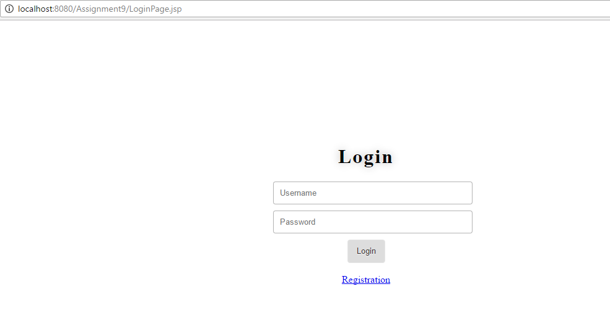

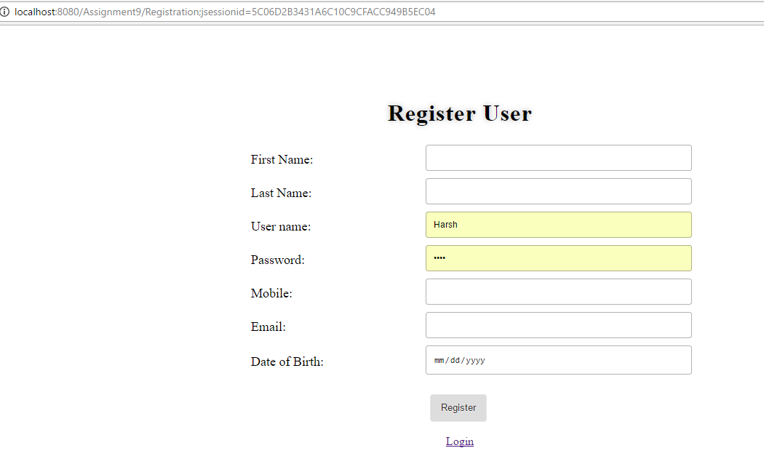

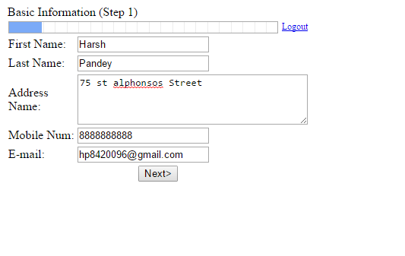

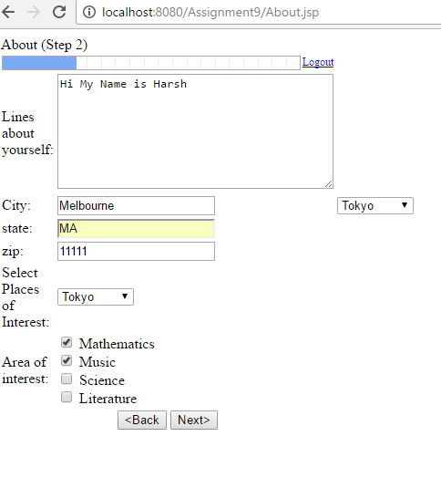

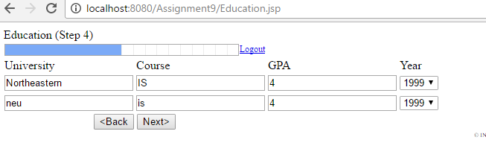

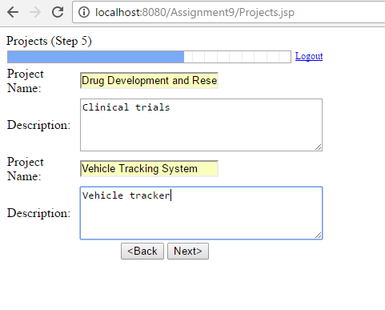

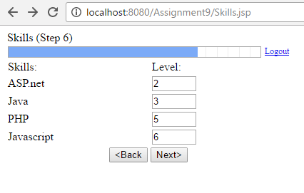

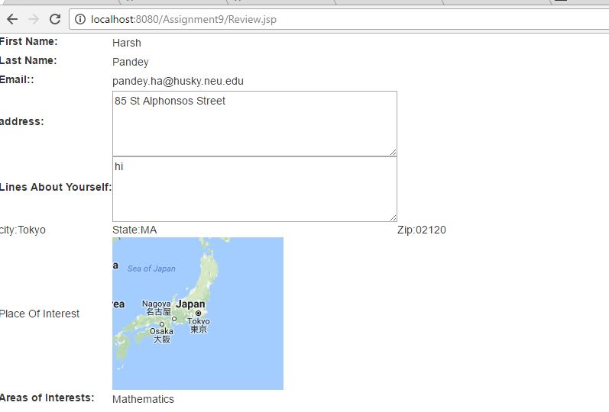

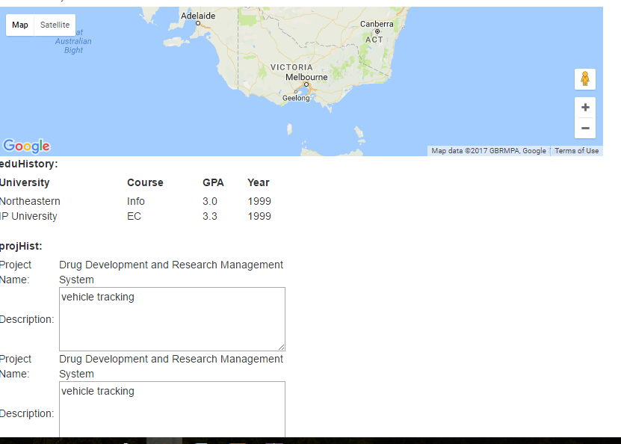

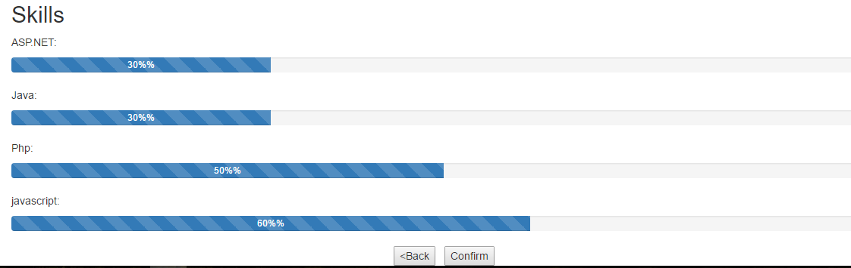

**DataBase Screenshot:**

